**Chandana Apparels**



**Payroll System**

**DCSD 12.2**

H.M.T. Gihan DKU122027

G.M.R.N. Ariyarathna DKU122006

I.D. J. Madhushan Wicramasinghe DKU122106

H.G Amal Jayawardhana DKU122046

National Institute Of Business Management

# Preface

A payroll system involves everything that has to be done with the payment of employees and filling of employee taxes and keeping tracks of hours, calculating wages, withholding taxes and other deductions, printing and delivering checks and paying employee taxes to the GVT and etc.

Considering all those above facts and the requirements of **Chandana Apparels**, we have successfully completed payroll software for their existing manual payroll system.

This is our DCSD 12.2 final group project for the Diploma in Computer System Designing at National Institute of Business Management Kurunegala. This project refers how we have done it step by step.

Our group members are:-

H.M.T. Gihan

G.M.R.N. Ariyarathna

H.G. Amal Jayaardhana

I.D. Janitha Madhushan

# Acknowledgement

We have taken efforts in this project. However, it would not have been possible without the kind support and help of many individuals and the organization. I would like to extend my sincere thanks to all of them.

We are highly indebted to **Chandana Apparels** and for their guidance and constant supervision as well as for providing necessary information regarding the project & also for their support in completing the project & employees of Chandana **Apparels** for their kind co-operation and encouragement which help me in completion of this project.

Special thanks go to Mr. Chandana Pathirana Kumara who is former manager of **Chandana Apparels**.

I would like to express my gratitude towards our course director of DCSD of NIBM Mr. Shafraz sir giving such a big opportunity to complete this project.

I would like to express my special gratitude and thanks to industry persons for giving me such attention and time including clerks, accountants, and employees too.

Our thanks and appreciations also go to my colleague in developing the project and people who have willingly helped me out with their abilities.

# Summary of the Project

This Project is about the payroll system of the **Chandana Apparels.**  And first we have discussed about the existing manual payroll system by dividing it in to 4 main processes. There we try to emphasize its drawbacks and difficulties they would face and the importance of a computerized payroll system.

Including all the information of an employee which is taken through the HRM Department and considering other necessary entities we have drawn dataflow diagrams. By drawing these diagrams we got the general structure of the payroll system. We have included many data stores to keep data separately so any one can get the idea easily. (Dataflow diagrams designed by MS Visio 2010)

Reading the company’s reports and bills etc, we have designed files and the interfaces. (Interfaces designed by Visual Studio 2010) After that according to the interfaces we wrote pseudo codes. Also we included real coding to some of our interfaces. And to get outputs we added a function to generate several reports as given below

* EPF and
* ETF Report
* OT Report
* No pay Report
* Pay Sheet
* Remittance Report

By considering these reports it is easy to find the needed details accurately and in efficient manner. Some of the reports have to send to central bank and also some are sent to the accountant and employee too. We successfully completed the project in this manner.

Finally we talked to the manager **Mr. Chandana Pathirana Kumara** and got his idea and we analyzed the benefits of the proposed system. And we included that one also

# CONTENTS

Title

1

2

3

7

8

9

10

12

13

Context Diagram for the existing system 14

15

17

18

Context Diagram for the Proposed System 22

23

24

25

26

28

29

47

48

88

110

116

124

127

128

**Cost and Advantages of the Proposed System**

129

130

132

# Chapter 1

# Introduction

# Terms of Reference

We got the legal permission from the **Chandana Apparels**. Then we proposed a new computerized payroll system for the manual system of their garment by considering their needs. Our main aim was to give the best way to accomplish their requirements.

Efficiency and accuracy is highly improved by this system. Inserting, Updating, Deleting, Searching processes can be done correctly and quickly. To implement this project we need hardware and software too. And also a trained employee is needed to handle this because money transaction is directly done through this system.

Via internet we got lot of information to succeed this project from the sites below.

* <http://en.wikipedia.org/wiki/Payroll>
* <http://www.ask.com/question/meaning-of-payroll-system>
* <http://www.sba.gov/content/10-steps-setting-payroll-system>
* <https://itservices.uchicago.edu/services/payroll-system-payrollpersonnel-system>
* <http://www.bestprojectsidea.com/vb-6-0-synopsis/employee-and-payroll-system/>

And also NIBM library was also very useful to use to gather data. Referring earlier projects and e-books we got the rough idea to make a good project. Here are the names of books we followed.

* Essentials of Payroll: Management and accounting by [Steven M. Bragg](http://www.google.lk/search?tbo=p&tbm=bks&q=inauthor:%22Steven+M.+Bragg%22) John Wiley & Sons, Apr 21, 2003.
* Payroll and Accounting by Frank C. Giove.
* [Payroll](http://books.google.lk/books?id=0gwZboBNf44C&source=gbs_book_similarbooks) by Vicki M. Lambert, IOMA

Some PowerPoint presentations were also referred by us on account of gathering information

# Feasibility Study

We have categorized this into several fields as given below.

* Technical Feasibility
* Legal Feasibility
* Economic Feasibility
* Operational Feasibility

Feasibility study was done by various methods such as interviewing, observing, record reading, reviving past records and etc. That was the first step we took to start our project. We interviewed manager, accountant, clerks, peon, other employees and etc. We spent more than 2 weeks to collect them and study them well together. We took such a long time because it was very important to see what they are looking for. Also we wanted to determine whether the company has the technical expertise to handle the software.

Then we proposed a new computerized payroll system to the above garment. The facts we considered were mainly accuracy and efficiency, way to get reports etc. Actually we studied the history of the garment too.

We determined whether the proposed system conflicts with legal requirements and focused on the technical resources of the garment and also we got a rough idea about the cost for our software and what they hope from us. Then we moved in to our next step.

The main purpose of the economic feasibility assessment is to determine the positive economic benefits to the organization that the proposed system will provide. It includes quantification and identification of all the benefits expected. This assessment typically involves a cost/ benefits analysis.

Operational feasibility is a measure of how well a proposed system solves the problems, and takes advantage of the opportunities identified during scope definition and how it satisfies the requirements identified in the requirements analysis phase of system development

Under above fields we were able to cover the weaknesses in the existing system and got a good idea about their needed system.

# Methodology

We have described this briefly in the Summery of the Project also.

After the Feasibility study we followed the steps of the System Development Life Cycle (SDLC). They were.

* Project Planning.
* Project Analysis.
* System Designing.

Then we used the main analysis technique, data flow diagrams (DFD) to show the processes of the system. We hope to use Microsoft Access to connect the database which includes all the information of Employees.

And we are going to use vb.net and C# languages to implement this software in runtime environment.

Following are steps we followed to give the best performing software.

1. Study the current procedures in the system.
2. Point the weaknesses of the prevailing system.
3. Identify new needs of the employees.
4. Provide simple and best software to the garment.

Show the advantages of the proposed one.

# Duration

After we collected enough data we started our project in middle of August month. We drew a rough project plan and share our ideas with our group members. This is how we spent time on the project.

Data Collection : 2 weeks

Data Analysis : 3 weeks

System Designing and Report Writing : 2 months

# Chapter 2

# Existing System

# History of the Organization

The wearing of clothing is exclusively a human characteristic and is a feature of most human societies. It is not known when humans began wearing clothes. [Anthropologists](http://en.wikipedia.org/wiki/Anthropology) believe that animal skins and vegetation were adapted into coverings as protection from cold, heat and rain, especially as humans migrated to new climates; alternatively, covering may have been invented first for other purposes, such as magic, decoration, cult, or prestige, and later found to be practical as well.

[Clothing](http://en.wikipedia.org/wiki/Clothing) and [textiles](http://en.wikipedia.org/wiki/Textile) have been important in human history and reflects the [materials](http://en.wikipedia.org/wiki/Material) available to a civilization as well as the technologies that it has mastered. The [social](http://en.wikipedia.org/wiki/Social) significance of the finished product reflects their [culture](http://en.wikipedia.org/wiki/Culture).

Textile industry is changing rapidly among people with the time. Nowadays people are looking for new fashionable clothing to act different and to keep their place in the society. Not like in early days, people have dozens of clothes and they offer may be half of their salary to shop keepers. This really has helped to widen this business in our country. And for that people have used many strategies to get the attention of people. This was the beginning of intercession of computerized systems in the industry to make them quick and accurate.

In 1999 Father of former manager at **Chandana Apparels** Mr. (name) started this garment at (place) with five workers and two sewing machines. But today this garment has provided more than 100 job opportunities. And they have uprooted their brand name somewhat too.

First this was started in a house and not so far away from the present location. But today it has spread over about 3 hectares with 5 sectors

* Cutting section
* Sawing section
* Stoking section
* Management section
* Security section

This garment provides many types of clothes such as baby, men, women and sport wearing to island wide shops. That the bit about the organization history.

# Existing System

Basic Salary

Salary is given to an employee according to their designation and qualifications.

Net Salary

This is calculated from basic salary after making increments and deductions.

Over Time

This is calculated when an employee has worked more than normal hours.

* OT payment = (basic salary/250)*No of OT Hours*1.5
* OT payment = (basic salary/250)*No of OT Hours*2 (for Poyadays, mercantile holidays….etc.)

No pay

This is considered in two ways.

* If an employee has taken more than medical or annual leave than the limit. Then no payment is given.
* If an employee hasn’t exceeded that limit then no pay amount is calculated as follows.

No Pay amount = (Basic Salary/25)*(No Pay days)

Leave

* Annual Leave – 14 days per a annum.
* Casual Leave – 7 days per annum after a year of service.
* Medical Leave – Maximum of 27 days per a annum and a illness should be supported by medical certificate from a registered medical practitioner.

Employee Provident Fund (E.P.F)

This deduction is done for 10% of the basic salary. And company pays 5% of employees basic salary to his E.P.F.

Employee Trust Fund (E.T.F)

This Deduction IS 3% of the basic salary. This is completely paid by the employee.

# Context Diagram of the Existing System



# Draw Backs

The manual payroll system increases the risk of payroll errors. It is not efficient for larger payrolls because of manual processing. Even for a small payroll, the likelihood of errors exists, due to dependence on human calculations. To reduce errors, the payroll representative must check the payroll multiple times before issuing paychecks, which is time consuming. It also does not enable direct deposit–an electronic and convenient method of paying employees. Paper checks increase the likelihood of stolen and counterfeit checks.

The in-house computerized system requires the employer to buy payroll software and pay an on-site payroll staff, which can be expensive, especially for a large payroll staff. If the software is complex, the employer may have to pay for additional training to the staff.   
.  
Since the payroll service provider operates from an off-site location it may be difficult for the employer to get immediate help when needed. Furthermore, if the payroll service makes payroll tax errors, the employer gets penalized, not the payroll provider.

Draw Backs of the Existing System we have identified and categorized as follow for easy identification.

* More time consuming
* Low accuracy
* High Redundancy.
* Security Problems.
* Wastage of more papers.
* High error rate.

# Chapter 3

# Proposed System

# Application Proposed

We have proposed a computerized payroll system for the existing system of Chandana Apparels to fulfill their requirements.

Our proposed system consists of 13 files. E use them to store employee details, leave info and data those are needed to make the calculation of salary. There must be a trained person to enter those details. Then the salary is calculated automatically by the system.

Once a payroll system is set up, the time taken to process a pay is less. You set up standard pays for people so that all allowances and deductions are processed without one thinking about it. Time is saved preparing pays and running the payroll so the employer saves money. All payroll records are held in one central place on a hard drive although it is still necessary to keep leave requests, printed pay summaries and copies of reports.

The most complicated area of payroll is working out the holiday pays (i.e. annual leave payments). Many get it wrong even using a computerized system Again, provided the set up is correct, processing holiday pays is a walk in the park compared to working them out manually. In Sri Lanka we are required to pay the **higher**of the average rate over the past 12 months or the normal (current) rate when an employee takes an annual leave day off. Imagine working this out manually.

And also it is easy to backup the payroll file for safe keeping. Paper based systems are not backed up, so if the pay book was lost or destroyed then the firm could face big problems.

This system is easy to use and also accuracy is very high when we compare with the existing manual system. And also we can generate reports quickly after entering those details. Human errors are also can be reduced by this software. And we have managed system to show error messages when we enter invalid data to the system. Therefore no invalid data can be entered. This is brief description about the proposed system.

# Security System

A payroll system needs security or controls so as to minimize or reduce the possibility of employees stealing and forging cheques. In addition, the system should have security so as to deny access to unauthorized persons.

Following were done when we designed the software.

Security measures can be implemented.

* Logging off the payroll system before leaving the computer
* Positioning the computer screen so that unauthorized persons cannot view the display
* Ensuring that confidential information cannot be viewed by unauthorized persons and is stored securely at the end of each day
* Not discussing the personal details of staff within hearing of unauthorized persons
* Ensuring that only authorized persons are given information regarding staff pay details
* Ensuring data is used only for the purposes for which it was intended.

We have used a login window in the beginning. Logged user can do these operations.

* Read
* Write
* Modify
* Delete

And also we have used an option to add new users and this can be only done by a logged user. Only administrator can accesses security system and this provides high security level for the system.

# Chapter 4

# Design of the Proposed System

# Chapter 4

# Design of the proposed system

# Dataflow Diagram

# Context Diagram of the Proposed System



# Level 0 DFD for Proposed System



# Level 1 DFD for the Salary Calculation Process



# Level 1 DFD for the EPF, ETF, OT, No pay Process



# Level 1 DFD for the Report Generation Process



## Chapter 4

## Design of the proposed system

## File Design

# Files List

|  |  |  |
| --- | --- | --- |
| **File No** | **File Name** | **Page No** |
| SF1 | Login | 28 |
| SF2 | Signup | 29 |
| D1 | Employee Master | 30 |
| D2 | Department | 31 |
| D3 | Leave Details | 32 |
| D4 | Promotion | 33 |
| D5 | Increment | 34 |
| D6 | Work Hour | 35 |
| D7 | Pay History | 36 |
| D8 | Rates Per Hour | 37 |
| D9 | Bonus | 38 |
| D10 | Salary | 39 |
| D11 | EPF | 40 |
| D12 | ETF | 41 |
| D13 | OT | 42 |
| D14 | No pay | 43 |

## Chapter 4

## Design of the proposed system

## Section File Design

## File Structures

# Login File

File No : SF1

File Name : Login File

Description : Username and password of the system

File Organization : Random

File Type : Reference File

Primary Key : UName

Foreign Key :

Record Size : 16 bytes

|  |  |  |  |
| --- | --- | --- | --- |
| Field Name | Description | Type | Size |
| UName | Username | Char | 10 |
| PWord | Password | Char | 6 |

# Signup File

File No : SF2

File Name : Signup File

Description : Username and password create for the system

File Organization : Random

File Type : Reference File

Primary Key : UName

Foreign Key :

Record Size : 16 bytes

|  |  |  |  |
| --- | --- | --- | --- |
| Field Name | Description | Type | Size |
| UName | Username | Char | 10 |
| PWord | Password | Char | 6 |

# Employ Master File

File No : D1

File Name : Employee Master

Description : Employee Personal File

File Organization : Indexed Sequential

File Type : Master File

Primary Key : EmpNo

Foreign Key : DeptNo, DesigNo

Record Size : 144 bytes

|  |  |  |  |
| --- | --- | --- | --- |
| Field Name | Description | Type | Size |
| EmpNo | Employee Number | Numeric | 5 |
| FName | First Name | Char | 15 |
| LName | Last Name | Char | 20 |
| AddL1 | Address Line 1 | Char | 15 |
| AddL2 | Address Line 2 | Char | 15 |
| NIC | NIC Number | Char | 10 |
| Sex | Male/Female | Char | 1 |
| DOB | Date Of Birth | Date | 8 |
| MStatus | Marriage Status | Char | 1 |
| DesigNo | Designation Number | Char | 10 |
| DeptNo | Department Number | Numeric | 4 |
| BSal | Basic Salary | Currency | 10 |
| DJoin | Date Joined | Date | 8 |
| Status | Permanent/Casual | Char | 1 |
| TelNo | Home Telephone No | Numeric | 10 |
| DiffTP | Office T/P No | Numeric | 10 |
| BaAcNo | Bank Account No | Numeric | 15 |

# Department File

File No : D2

File Name : Department File

Description : Department reference File

File Organization : Indexed Sequential

File Type : Reference File

Primary Key : DeptNo

Foreign Key :

Record Size : 20 bytes

|  |  |  |  |
| --- | --- | --- | --- |
| Field Name | Description | Type | Size |
| DeptNo | Department No | Char | 4 |
| DeptName | Department Name | Char | 16 |

# Leave Detail File

File No : D3

File Name : Leave detail File

Description : Leave Transaction File

File Organization : Indexed Sequential

File Type : Transaction File

Primary Key : Month

Foreign Key : EmpNo

Record Size : 16 bytes

|  |  |  |  |
| --- | --- | --- | --- |
| Field Name | Description | Type | Size |
| EmpNo | Employee Number | Numeric | 5 |
| Year | Year | Numeric | 4 |
| Month | Month | Numeric | 2 |
| NoLeaves | No of Leaves | Numeric | 2 |
| NoPay | No of no pay days | Numeric | 3 |

# Promotion File

File No : D4

File Name : Promotion File

Description : Promotion Data Of Employee

File Organization : Indexed Sequential

File Type : Transaction File

Primary Key : PromoDate

Foreign Key : EmpNo , DeptNo

Record Size : 37 bytes

|  |  |  |  |
| --- | --- | --- | --- |
| Field Name | Description | Type | Size |
| EmpNo | Employee Number | Numeric | 5 |
| DeptNo | Department Number | Char | 4 |
| PromoDate | Promoted Date | Date | 8 |
| Description | Remarks | Char | 20 |

# Increment File

File No : D5

File Name : Increment File

Description : Increment Data Of Employee

File Organization : Indexed Sequential

File Type : Transaction File

Primary Key : DeptNo

Foreign Key : EmpNo

Record Size : 35 bytes

|  |  |  |  |
| --- | --- | --- | --- |
| Field Name | Description | Type | Size |
| EmpNo | Employee Number | Numeric | 5 |
| DeptNo | Department Number | Char | 4 |
| IncreAmt | Increment Amount | Currency | 8 |
| BSal | Basic Salary | Currency | 10 |
| IncreDate | Increment Date | Date | 8 |

# Work Hour File

File No : D6

File Name : Work Hour File

Description : Details about worked hour of employees

File Organization : Random

File Type : Transaction File

Primary Key : Month

Foreign Key : EmpNo

Record Size : 21 bytes

|  |  |  |  |
| --- | --- | --- | --- |
| Field Name | Description | Type | Size |
| EmpNo | Employee Number | Numeric | 5 |
| Year | Year | Numeric | 4 |
| Month | Month | Numeric | 2 |
| Hours | No of extra hours | Numeric | 10 |

# Pay History File

File No : D7

File Name : Pay History File

Description : Details about pay history of employees

File Organization : Random

File Type : Transaction File

Primary Key : Month

Foreign Key : EmpNo

Record Size : 41 bytes

|  |  |  |  |
| --- | --- | --- | --- |
| Field Name | Description | Type | Size |
| EmpNo | Employee Number | Numeric | 5 |
| Year | Year | Numeric | 4 |
| Month | Month | Numeric | 2 |
| NetPay | NetPay | Currency | 10 |
| TEarn | Total Earning | Currency | 10 |
| TDeduct | Total Deductions | Currency | 10 |

# Rates per Hour File

File No : D8

File Name : Rates Per Hour File

Description : Rates paid per hour to the employee

File Organization : Random

File Type : Reference File

Primary Key : Rate

Foreign Key : Status

Record Size : 20 bytes

|  |  |  |  |
| --- | --- | --- | --- |
| Field Name | Description | Type | Size |
| Status | Post | Char | 10 |
| Rate | Rate per hour | Numeric | 10 |

# Bonus File

File No : D9

File Name : Bonus File

Description : Amount of bonus to the employee

File Organization : Random

File Type : Transaction File

Primary Key : Date

Foreign Key : EmpNo

Record Size : 22 bytes

|  |  |  |  |
| --- | --- | --- | --- |
| Field Name | Description | Type | Size |
| EmpNo | Employee Number | Numeric | 4 |
| Date | Date Paid | Date | 8 |
| Amt | Amount Paid | Numeric | 10 |

# Salary File

File No : D10

File Name : Salary File

Description : Details of the salary paid to the employees

File Organization : Indexed Sequential

File Type : Transaction File

Primary Key : Month

Foreign Key : EmpNo

Record Size : 61 bytes

|  |  |  |  |
| --- | --- | --- | --- |
| Field Name | Description | Type | Size |
| EmpNo | Employee Number | Numeric | 5 |
| Year | Year | Numeric | 4 |
| Month | Month | Numeric | 2 |
| BSal | Basic Salary | Currency | 10 |
| TEarns | Total Earnings | Currency | 10 |
| GSal | Gross Salary | Currency | 10 |
| TDeduct | Total Deductions | Currency | 10 |
| NetSal | NetSalary | Currency | 10 |

# EPF File

File No : D11

File Name : EPF File

Description : Details of EPF Contribution of employees

File Organization : Indexed Sequential

File Type : Transaction File

Primary Key : EPFNo

Foreign Key : EmpNo

Record Size : 21 bytes

|  |  |  |  |
| --- | --- | --- | --- |
| Field Name | Description | Type | Size |
| EmpNo | Employee Number | Numeric | 5 |
| EPFNo | Employee Provident Fund Number | Numeric | 4 |
| Month | Month | Numeric | 2 |
| EMPIRate | Employer’s Rate | Numeric | 5 |
| EmplyeeRate | Employees Rate | Numeric | 5 |

# ETF File

File No : D12

File Name : ETF File

Description : Details of ETF Contribution of employees

File Organization : Indexed Sequential

File Type : Transaction File

Primary Key : ETFNo

Foreign Key : EmpNo

Record Size : 22 bytes

|  |  |  |  |
| --- | --- | --- | --- |
| Field Name | Description | Type | Size |
| EmpNo | Employee Number | Numeric | 5 |
| ETFNo | Employee Trust Fund Number | Numeric | 4 |
| Month | Month | Date | 8 |
| EMPIRate | Employer’s Rate | Numeric | 5 |

# OT File

File No : D13

File Name : OT File

Description : OT Details of employees

File Organization : Indexed Sequential

File Type : Transaction File

Primary Key : Month

Foreign Key : EmpNo

Record Size : 33 bytes

|  |  |  |  |
| --- | --- | --- | --- |
| Field Name | Description | Type | Size |
| EmpNo | Employee Number | Numeric | 5 |
| Year | Year | Numeric | 4 |
| Month | Month | Date | 8 |
| OT Hour | Number of OT Hour | Numeric | 4 |
| OT Rate | OT Rate Per Hour | Numeric | 4 |
| Amount | Amount | Numeric | 8 |

# No Pay File

File No : D14

File Name : No Pay File

Description : No Pay Details of employees

File Organization : Indexed Sequential

File Type : Transaction File

Primary Key : Year

Foreign Key : EmpNo

Record Size : 21 bytes

|  |  |  |  |
| --- | --- | --- | --- |
| Field Name | Description | Type | Size |
| EmpNo | Employee Number | Numeric | 5 |
| Year | Year | Numeric | 4 |
| Month | Month | Date | 8 |
| NPDays | No Pay Days | Numeric | 4 |

## Chapter 4 Design of the proposed system

## Programs

# Programs List

|  |  |  |
| --- | --- | --- |
| **Program No** | **Program Name** | **Page No** |
| P1 | Login | 47 |
| P2 | Signup | 48 |
| P3 | Main Form | 49 |
| P4 | Search | 50 |
| P5 | Maintenances | 52 |
| P6 | Reports | 54 |
| P7 | Tool | 56 |
| P8 | Employee Master | 57 |
| P9 | Department | 59 |
| P10 | Pay History | 61 |
| P11 | Rates Per Hour | 63 |
| P12 | Bonus | 65 |
| P13 | Salary | 67 |
| P14 | EPF | 69 |
| P15 | ETF | 71 |
| P16 | OT | 73 |
| P17 | No pay | 75 |
| P18 | Leave Details | 77 |
| P19 | Work Hour | 79 |
| P20 | Increment | 81 |
| P21 | Promotion | 83 |

### Chapter 4

### Design of the proposed system

### Section Programs

### Programs Structures

# Program 1 Login

Program ID : 01

Description : Login Check

Screen Name : Screen 1

Input File : Login File

Output File :

Output Report :

Begin program

Display Screen (S1)

Input username and password

if log Button Clicked

if any textboxes are empty then

Display Message Screen (MS 1)

else

Open Login File

seek Uname=File UName and PWord=File PWord

If Username and Password Not Found then

Display Error Message (MS 7)

Else

Display Screen (MS 9)

End if

End if

Else If ClearButton Clicked

Clear Textbox1 and Textbox2

Else if AddUserButton Clicked

Display Screen (S2)

End if

End Program

# Program 2 Signup

Program ID : 02

Description : Signup Check

Screen Name : Screen 02

Input File : Signup File

Output File :

Output Report :

Begin program

Display Screen (S1)

Input username and password

If Sign up Button Clicked

if any textboxes are empty then

Display Message Screen (MS 1)

Else

Open Signup File

Find Uname and PWord=File UName,PWord

If Username and Password Not Found then

Display Error Message (MS 7)

Else

Display Screen (S 3)

End if

End if

Else If Clear Button Clicked

Clear Textbox1 and Textbox2

End if

End Program

# Program 3 Main Form

Program ID : 03

Description : Main Form

Screen Name : Screen 03

Input File :

Output File :

Output Report :

Begin program

Display Screen (S 3)

Input username and password

if Search Button Clicked

Display Screen(S 4)

Else If Maintenance Button Clicked

Display Screen(S 8)

Else If Report Button Clicked

Display Screen(S 6)

Else If Tools Button Clicked

Display Screen(S 7)

Else If Back Button Clicked

Display Screen(S 1)

Else If Exit Button Clicked

End Program

# Program 4 Search

Program ID : 04

Description : Search

Screen Name : Screen 04

Input File : Employee Master File

Output File :

Output Report :

Begin program

Display Screen (S 4)

Input Emp_No

if Search Button Clicked

if EMp_No Text box Empty then

Display Message Screen (MS 1)

Else

Open Employee Master File

Seek Emp_No=File Emp_No

if Found then

Get Information into Grid View

Display Grid View

Else

Display Message Screen (MS 6)

End if

End if

If Grid view Row Double Clicked then

Get all Information from Selected row

Send to Employee master textboxes

End if

# Program 5 Maintenances

Program ID : 05

Description : Maintenance Menu

Screen Name : Screen 5

Input File :

Output File :

Output Report :

Begin program

If Employee Master Button Clicked

Display Screen(S 8)

Else if Work hour Button clicked

Display Screen(S 18)

Else If EPF Details Button Clicked

Display Screen(S 14)

Else If ETF Details Button Clicked

Display Screen(S 15)

Else If Department Details Button Clicked

Display Screen(S 9)

Else If Pay history Button Clicked

Display Screen(S 10)

Else If OT Details Button Clicked

Display Screen(S 16)

Else If Leave Details Button Clicked

Display Screen(S 19)

Else If EPF Rates per hour Button Clicked

Display Screen(S 11)

Else If No pay Details Button Clicked

Display Screen(S 17)

Else If Promotion Details Button Clicked

Display Screen(S 21)

Else If Salary Details Button Clicked

Display Screen(S 13)

Else If Bonus Details Button Clicked

Display Screen(S 12)

Else If Increment Details Button Clicked

Display Screen(S 20)

Else If ETF Details Button Clicked

Display Screen(S 15)

Else If Back Button Clicked

Display Screen(S 1)

Else If Exit Button Clicked

End Program

End if

End Program

# Program 6 Report

Program ID : 06

Description : Report Menu

Screen Name : Screen 6

Input File :

Output File :

Output Report :

Begin program

If ETF Report Button Clicked

Display Screen(S 22)

Else if Payment List Button clicked

Display Screen(S 23)

Else If EPF Report Button Clicked

Display Screen(S 24)

Else If ETF Report Button Clicked

Display Screen(S 25)

Else If OT Report Button Clicked

Display Screen(S 26)

Else If Day Report Button Clicked

Display Screen(S 27)

Else If No Pay Report Button Clicked

Display Screen(S 28)

Else If Back Button Clicked

Display Screen(S 1)

Else If Exit Button Clicked

End Program

End if

End Program

# Program 6 Tools

Program ID : 06

Description : Tools

Screen Name : Screen 6

Input File :

Output File :

Output Report :

Begin program

If about Button Clicked

Display About

Else if Help Button clicked

Display Help

Else If Change Password Button Clicked

If any textboxes are empty then

Display Message Screen (MS 1)

Else

Open signup File

Seek UName=current user name textbox

PWord= current password textbox

Update record to file

End if

End if

End program

# Program 8 Maintenance > Employee Master

Program ID : 08

Description : Employee master

Screen Name : Screen 08

Input File : Employee Master File

Output File :

Output Report :

Begin program

Open Employee master file

Display Screen (S 8)

Input all textboxes data

if Add Button Clicked

if any textboxes are empty then

Display Message Screen (MS 1)

Else if already exist data found then

Display Message Screen (MS 2)

Else

Write record to file

Display Message Screen (MS 3)

End if

Else If Modify Button Clicked

if any textboxes are empty then

Display Message Screen (MS 1)

Else if already Exist data found then

Display Message Screen (MS 2)

Else

Update record to file

Display Message Screen (MS 4)

End if

Else if Delete Button Clicked

Seek record from file

if Emp_No= File Emp_No

Delete record from file

Display Message Screen (MS 5)

End if

Else if Find Button Clicked then

Display Screen (S 4)

End if

End Program

# Program 9 Maintenance > Department

Program ID : Program 09

Description : Department

Screen Name : Screen 9

Input File : Department File

Output File :

Output Report :

Begin program

Open Department file

Display Screen (S 9)

Input Dept_code and Dept_name

if Add Button Clicked

if any textboxes are empty then

Display Message Screen (MS 1)

Else if already exist data found then

Display Message Screen (MS 2)

Else

Write record to file

Display Message Screen (MS 3)

End if

Else If Modify Button Clicked

if any textboxes are empty then

Display Message Screen (MS 1)

Else if already Exist data found then

Display Message Screen (MS 2)

Else

Update record to file

Display Message Screen (MS 4)

End if

Else if Delete Button Clicked

Seek record from file

if Emp_No= File Emp_No

Delete record from file

Display Message Screen (MS 5)

End if

Else if Find Button Clicked then

Display Screen (S 4)

End if

End Program

# Program 10 Maintenance > Pay History

Program ID : Program 10

Description : Pay History

Screen Name : Screen 10

Input File : Pay History File

Output File :

Output Report :

Begin program

Display Screen (S 10)

Open Pay history File

Input all textboxes Data

if Add Button Clicked

if any textboxes are empty then

Display Message Screen (MS 1)

Else if already exist data found then

Display Message Screen (MS 2)

Else

Write record to file

Display Message Screen (MS 3)

End if

Else If Modify Button Clicked

if any textboxes are empty then

Display Message Screen (MS 1)

Else if already Exist data found then

Display Message Screen (MS 2)

Else

Update record to file

Display Message Screen (MS 4)

End if

Else if Delete Button Clicked

Seek record from file

if Emp_No= File >Emp_No

Delete record from file

Display Message Screen (MS 5)

End if

Else if Find Button Clicked then

Display Screen (S 4)

End if

End Program

# Program 11 Maintenance > Rates per hour

Program ID : Program 11

Description : Rates per hour

Screen Name : Screen 11

Input File : Rates Per Hour Detail File

Output File :

Output Report :

Begin program

Display Screen (S 11)

Open Rates per hour File

Input all textboxes Data

if Add Button Clicked

if any textboxes are empty then

Display Message Screen (MS 1)

Else if already exist data found then

Display Message Screen (MS 2)

Else

Write record to file

Display Message Screen (MS 3)

End if

Else If Modify Button Clicked

if any textboxes are empty then

Display Message Screen (MS 1)

Else if already Exist data found then

Display Message Screen (MS 2)

Else

Update record to file

Display Message Screen (MS 4)

End if

Else if Delete Button Clicked

Seek record from file

if Emp_No= File >Emp_No

Delete record from file

Display Message Screen (MS 5)

End if

Else if Find Button Clicked then

Display Screen (S 4)

End if

End Program

# Program 12 Maintenance > Bonus

Program ID : Program 12

Description : Bonus

Screen Name : Screen 12

Input File : Bonus Detail File

Output File :

Output Report :

Begin program

Display Screen (S 12)

Open Bonus File

Input all textboxes Data

if Add Button Clicked

if any textboxes are empty then

Display Message Screen (MS 1)

Else if already exist data found then

Display Message Screen (MS 2)

Else

Write record to file

Display Message Screen (MS 3)

End if

Else If Modify Button Clicked

if any textboxes are empty then

Display Message Screen (MS 1)

Else if already Exist data found then

Display Message Screen (MS 2)

Else

Update record to file

Display Message Screen (MS 4)

End if

Else if Delete Button Clicked

Seek record from file

if Emp_No= File >Emp_No

Delete record from file

Display Message Screen (MS 5)

End if

Else if Find Button Clicked then

Display Screen (S 4)

End if

End Program

# Program 13 Maintenance > Salary

Program ID : Program 13

Description : Salary Details

Screen Name : Screen 13

Input File : Salary File

Output File :

Output Report :

Begin program

Display Screen (S 13)

Open Salary File

Input all textboxes Data

if Add Button Clicked

if any textboxes are empty then

Display Message Screen (MS 1)

Else if already exist data found then

Display Message Screen (MS 2)

Else

Write record to file

Display Message Screen (MS 3)

End if

Else If Modify Button Clicked

if any textboxes are empty then

Display Message Screen (MS 1)

Else if already Exist data found then

Display Message Screen (MS 2)

Else

Update record to file

Display Message Screen (MS 4)

End if

Else if Delete Button Clicked

Seek record from file

if Emp_No= File >Emp_No

Delete record from file

Display Message Screen (MS 5)

End if

Else if Find Button Clicked then

Display Screen (S 4)

End if

End Program

# Program 14 Maintenance > EPF

Program ID : Program 14

Description : EPF

Screen Name : Screen 14

Input File : EPF Detail File

Output File :

Output Report :

Begin program

Display Screen (S 14)

Open EPF File

Input all textboxes Data

if Add Button Clicked

if any textboxes are empty then

Display Message Screen (MS 1)

Else if already exist data found then

Display Message Screen (MS 2)

Else

Write record to file

Display Message Screen (MS 3)

End if

Else If Modify Button Clicked

if any textboxes are empty then

Display Message Screen (MS 1)

Else if already Exist data found then

Display Message Screen (MS 2)

Else

Update record to file

Display Message Screen (MS 4)

End if

Else if Delete Button Clicked

Seek record from file

if Emp_No= File >Emp_No

Delete record from file

Display Message Screen (MS 5)

End if

Else if Find Button Clicked then

Display Screen (S 4)

End if

End Program

# Program 15 Maintenance > ETF

Program ID : Program 15

Description : ETF

Screen Name : Screen 15

Input File : ETF Detail File

Output File :

Output Report :

Begin program

Display Screen (S 15)

Open ETF File

Input all textboxes Data

if Add Button Clicked

if any textboxes are empty then

Display Message Screen (MS 1)

Else if already exist data found then

Display Message Screen (MS 2)

Else

Write record to file

Display Message Screen (MS 3)

End if

Else If Modify Button Clicked

if any textboxes are empty then

Display Message Screen (MS 1)

Else if already Exist data found then

Display Message Screen (MS 2)

Else

Update record to file

Display Message Screen (MS 4)

End if

Else if Delete Button Clicked

Seek record from file

if Emp_No= File >Emp_No

Delete record from file

Display Message Screen (MS 5)

End if

Else if Find Button Clicked then

Display Screen (S 4)

End if

End Program

# Program 16 Maintenance > OT

Program ID : Program 16

Description : OT

Screen Name : Screen 16

Input File : OT File

Output File :

Output Report :

Begin program

Display Screen (S 13)

Open OT File

Input all textboxes Data

if Add Button Clicked

if any textboxes are empty then

Display Message Screen (MS 1)

Else if already exist data found then

Display Message Screen (MS 2)

Else

Write record to file

Display Message Screen (MS 3)

End if

Else If Modify Button Clicked

if any textboxes are empty then

Display Message Screen (MS 1)

Else if already Exist data found then

Display Message Screen (MS 2)

Else

Update record to file

Display Message Screen (MS 4)

End if

Else if Delete Button Clicked

Seek record from file

if Emp_No= File Emp_No

Delete record from file

Display Message Screen (MS 5)

End if

Else if Find Button Clicked then

Display Screen (S 4)

End if

End Program

# Program 17 Maintenance Employee > No pay

Program ID : Program 17

Description : No Pay

Screen Name : Screen 17

Input File : No Pay Detail File

Output File :

Output Report :

Begin program

Display Screen (S 17)

Open No pay File

Input all textboxes Data

if Add Button Clicked

if any textboxes are empty then

Display Message Screen (MS 1)

Else if already exist data found then

Display Message Screen (MS 2)

Else

Write record to file

Display Message Screen (MS 3)

End if

Else If Modify Button Clicked

if any textboxes are empty then

Display Message Screen (MS 1)

Else if already Exist data found then

Display Message Screen (MS 2)

Else

Update record to file

Display Message Screen (MS 4)

End if

Else if Delete Button Clicked

Seek record from file

if Emp_No= File >Emp_No

Delete record from file

Display Message Screen (MS 5)

End if

Else if Find Button Clicked then

Display Screen (S 4)

End if

End Program

# Program 18 Maintenance > Leave Details

Program ID : Program 18

Description : Leave Details

Screen Name : Screen 18

Input File : Leave Details File

Output File :

Output Report :

Begin program

Display Screen (S 18)

Open Leave details File

Input all textboxes Data

if Add Button Clicked

if any textboxes are empty then

Display Message Screen (MS 1)

Else if already exist data found then

Display Message Screen (MS 2)

Else

Write record to file

Display Message Screen (MS 3)

End if

Else If Modify Button Clicked

if any textboxes are empty then

Display Message Screen (MS 1)

Else if already Exist data found then

Display Message Screen (MS 2)

Else

Update record to file

Display Message Screen (MS 4)

End if

Else if Delete Button Clicked

Seek record from file

if Emp_No= File >Emp_No

Delete record from file

Display Message Screen (MS 5)

End if

Else if Find Button Clicked then

Display Screen (S 4)

End if

End Program

# Program 19 Maintenance > Work Hour

Program ID : Program 19

Description : Wok hour

Screen Name : Screen 19

Input File : Work Hour Detail File

Output File :

Output Report :

Begin program

Display Screen (S 19)

Open Work hour File

Input all textboxes Data

if Add Button Clicked

if any textboxes are empty then

Display Message Screen (MS 1)

Else if already exist data found then

Display Message Screen (MS 2)

Else

Write record to file

Display Message Screen (MS 3)

End if

Else If Modify Button Clicked

if any textboxes are empty then

Display Message Screen (MS 1)

Else if already Exist data found then

Display Message Screen (MS 2)

Else

Update record to file

Display Message Screen (MS 4)

End if

Else if Delete Button Clicked

Seek record from file

if Emp_No= File >Emp_No

Delete record from file

Display Message Screen (MS 5)

End if

Else if Find Button Clicked then

Display Screen (S 4)

End if

End Program

# Program 20 Maintenance > Increment

Program ID : Program 20

Description : Increment

Screen Name : Screen 20

Input File : Increment File

Output File :

Output Report :

Begin program

Display Screen (S 20)

Open Increment File

Input all textboxes Data

if Add Button Clicked

if any textboxes are empty then

Display Message Screen (MS 1)

Else if already exist data found then

Display Message Screen (MS 2)

Else

Write record to file

Display Message Screen (MS 3)

End if

Else If Modify Button Clicked

if any textboxes are empty then

Display Message Screen (MS 1)

Else if already Exist data found then

Display Message Screen (MS 2)

Else

Update record to file

Display Message Screen (MS 4)

End if

Else if Delete Button Clicked

Seek record from file

if Emp_No= File Emp_No

Delete record from file

Display Message Screen (MS 5)

End if

Else if Find Button Clicked then

Display Screen (S 4)

End if

End Program

# Program 21 Maintenance > Promotion

Program ID : Program 21

Description : Promotion

Screen Name : Screen 21

Input File : Department File

Output Fie :

Output Report :

Begin program

Display Screen (S 21)

Open Promotion File

Input all textboxes Data

if Add Button Clicked

if any textboxes are empty then

Display Message Screen (MS 1)

Else if already exist data found then

Display Message Screen (MS 2)

Else

Write record to file

Display Message Screen (MS 3)

End if

Else If Modify Button Clicked

if any textboxes are empty then

Display Message Screen (MS 1)

Else if already Exist data found then

Display Message Screen (MS 2)

Else

Update record to file

Display Message Screen (MS 4)

End if

Else if Delete Button Clicked

Seek record from file

if Emp_No= File >Emp_No

Delete record from file

Display Message Screen (MS 5)

End if

Else if Find Button Clicked then

Display Screen (S 4)

End if

End Program

## Chapter 4

## Design of the proposed system

## Screens

# Screen List

|  |  |  |
| --- | --- | --- |
| **Screen No** | **Screen Name** | **Page No** |
| S1 | Login | 87 |
| S2 | Signup | 88 |
| S3 | Main Form | 89 |
| S4 | Search | 90 |
| S5 | Maintenances | 91 |
| S6 | Reports | 92 |
| S7 | Tools | 93 |
| S8 | Employee Master | 94 |
| S9 | Department | 95 |
| S10 | Pay History | 96 |
| S11 | Rates Per Hour | 97 |
| S12 | Bonus | 98 |
| S13 | Salary | 99 |
| S14 | EPF | 100 |
| S15 | ETF | 101 |
| S16 | OT | 102 |
| S17 | No pay | 103 |
| S18 | Work Hour | 104 |
| S19 | Leave Details | 105 |
| S20 | Increment | 106 |
| S21 | Promotion | 107 |
| S22 | Report Viewer | 108 |

# Screen 01 Logging

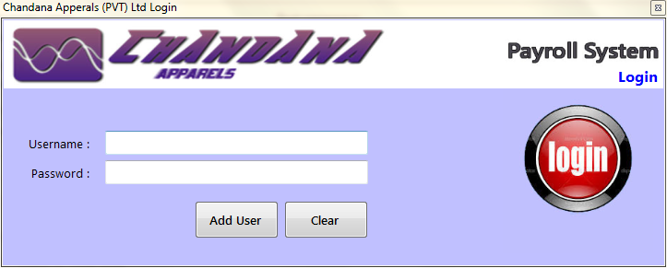

# Screen 02 Signup

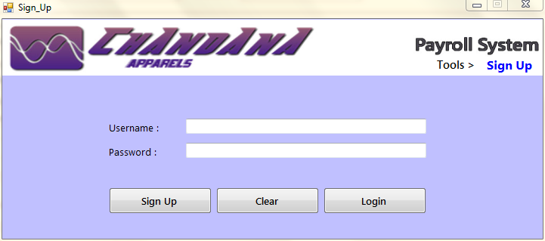

# Screen 03 Main Form

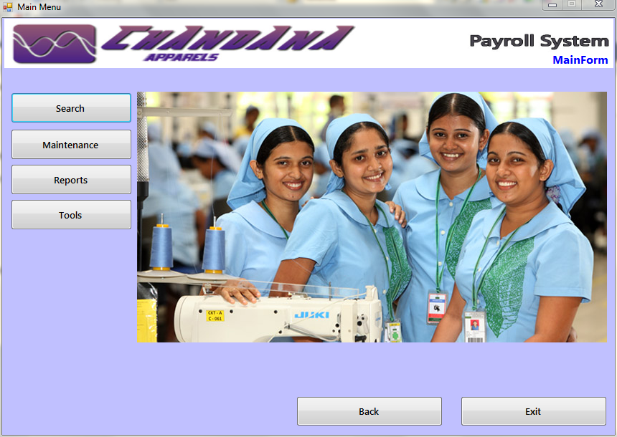

# Screen 04 Search

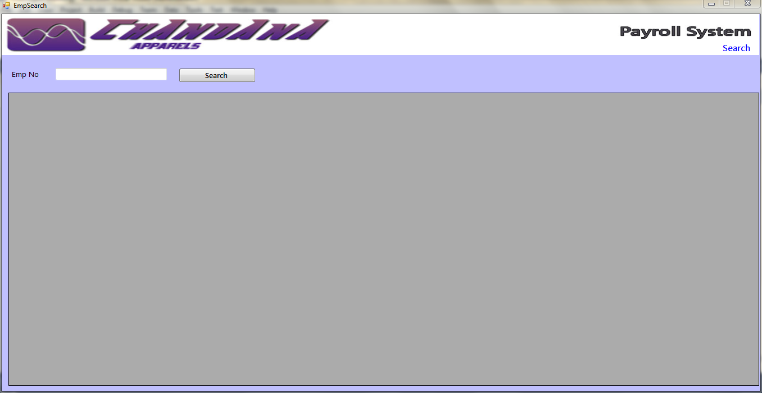

# Screen 05 Maintenances

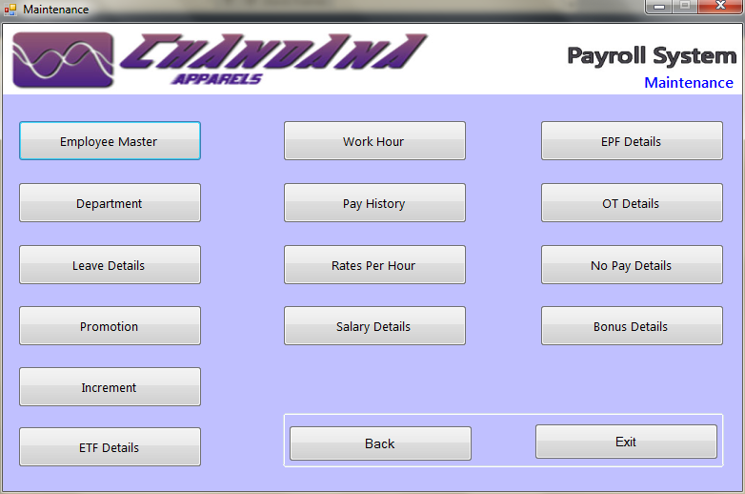

# Screen 06 Reports

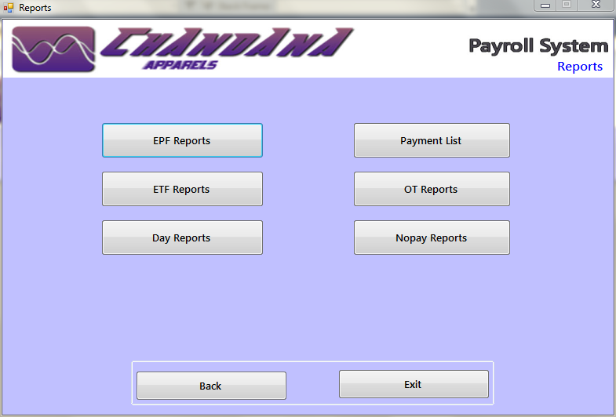

# Screen 07 Tools

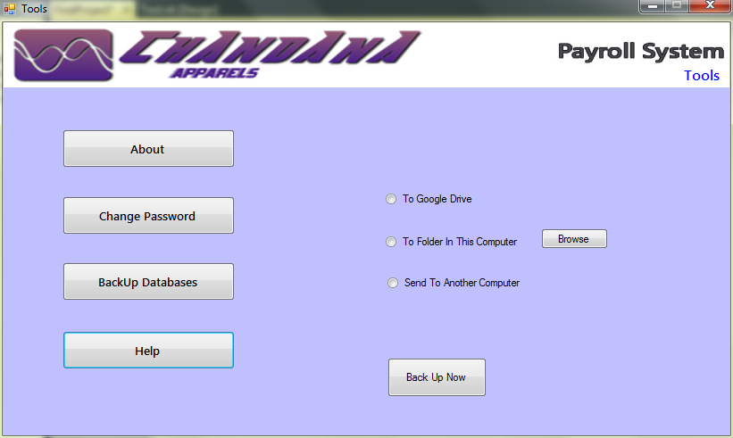

# Screen 08 Employee Master

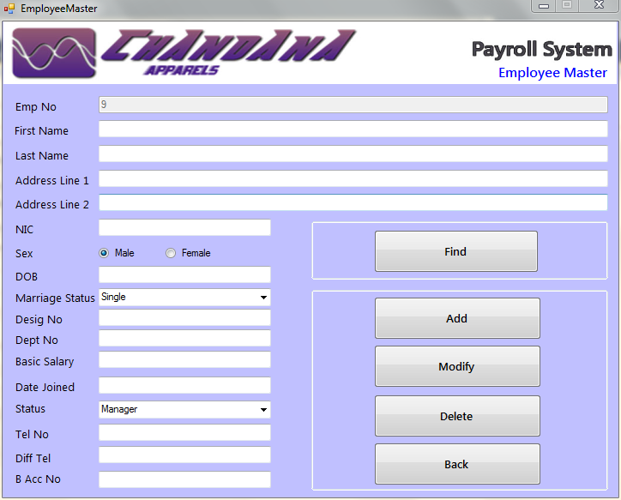

# Seen 09 Department

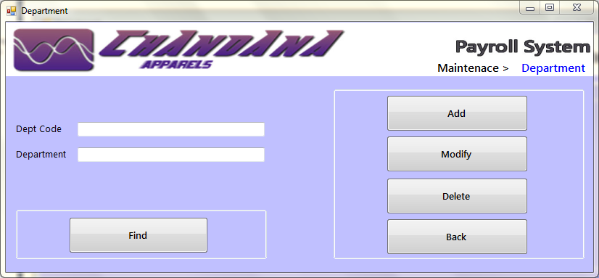

# Screen 10 Pay history

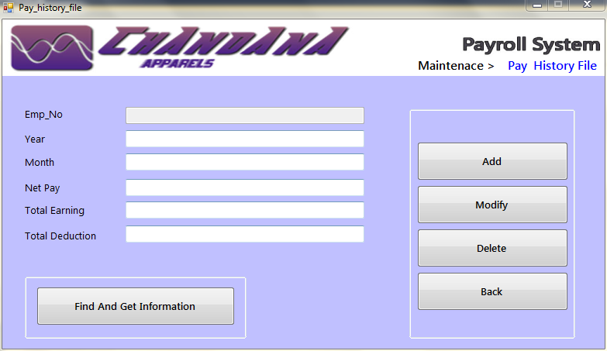

# Screen 02 Rates per hour

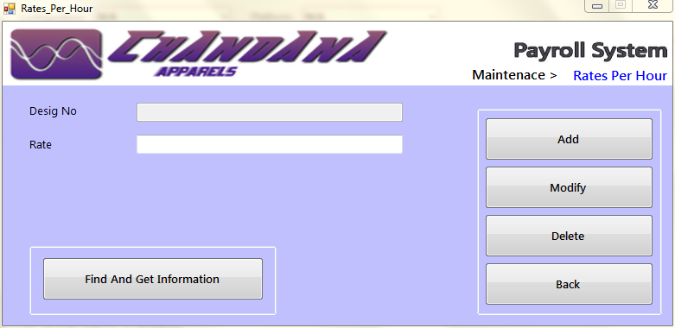

# Screen 12 Bonus

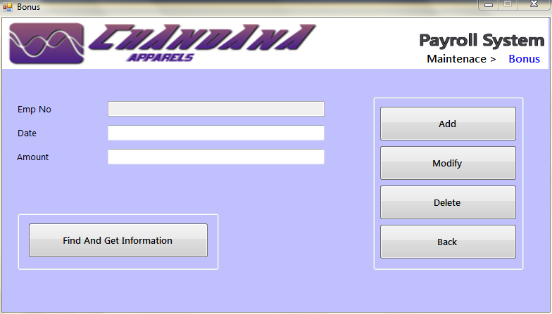

# Screen 13 Salary

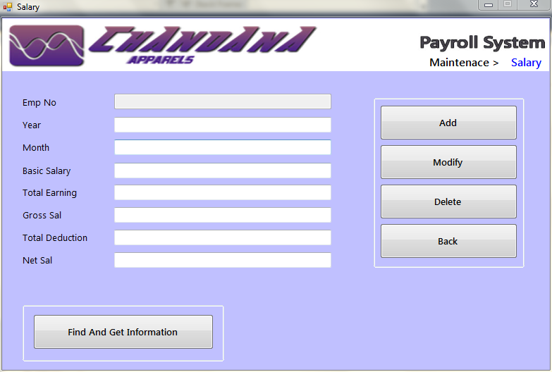

# Screen 14 EPF

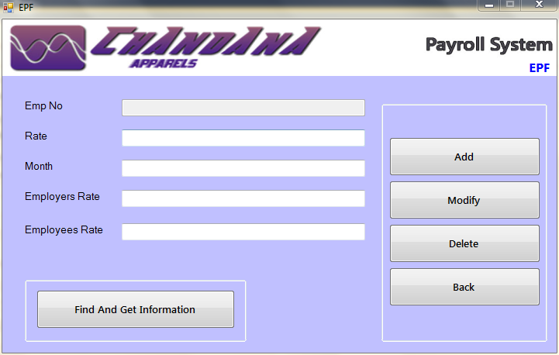

# Screen 15 ETF

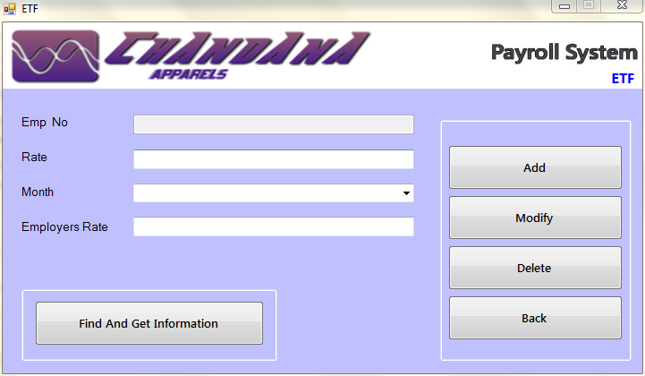

# Screen 16 OT

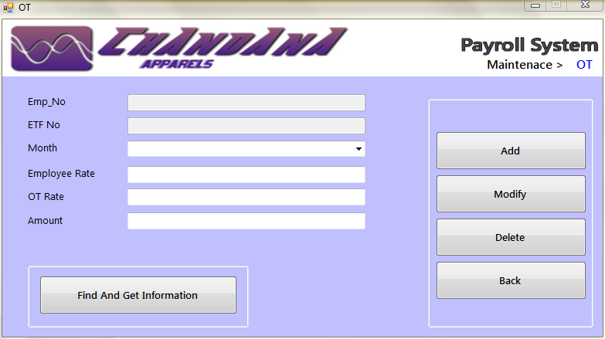

# Screen 17 No pay

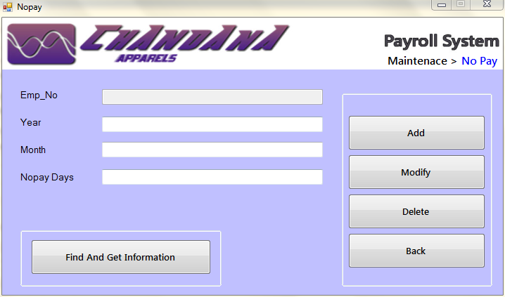

# Screen 18 Work hour

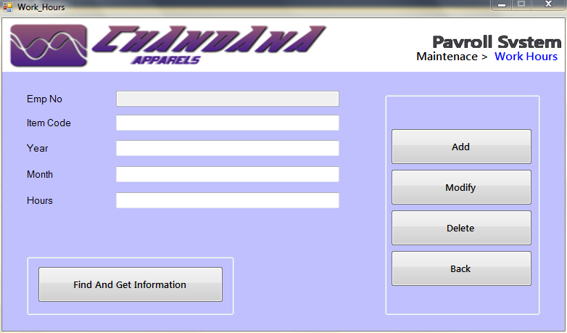

# Screen 19 Leave Details

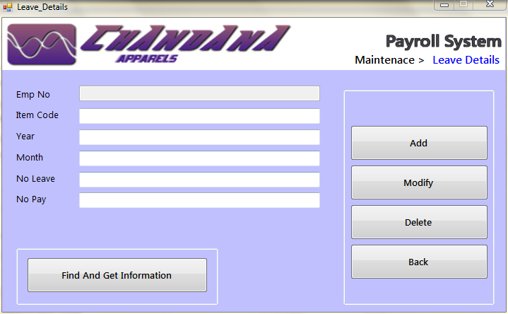

# Screen 20 Increment

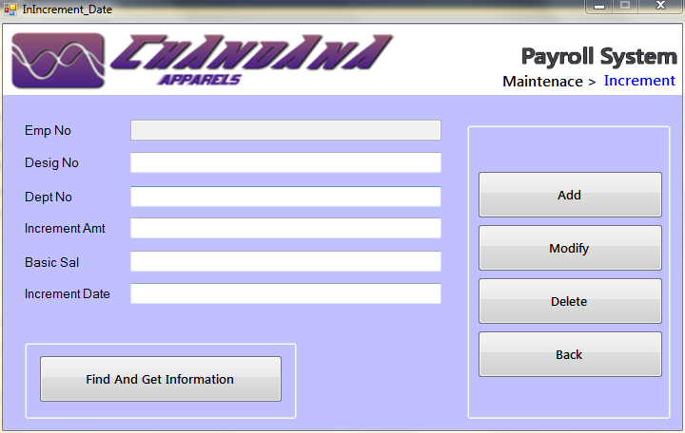

# Screen 21 Promotion

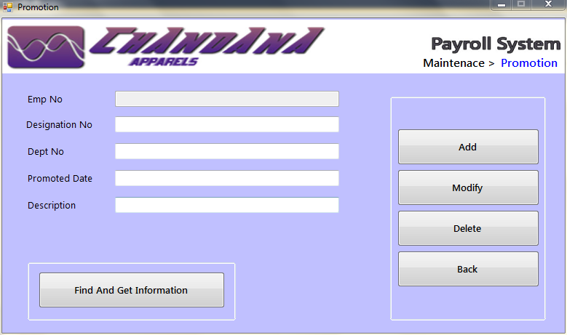

# reportviewer.PNGScreen 22 Report Viewer

# Message Screen List

|  |  |  |
| --- | --- | --- |
| **Screen No** | **Screen Name** | **Page No** |
| MS1 | No Input | 109 |
| MS2 | Already Exist | 110 |
| MS3 | Record Added Successfully | 111 |
| MS4 | Record Update Successfully | 112 |
| MS5 | Record Delete Successfully | 113 |
| MS6 | Invalid Input | 114 |
| MS7 | Authentication Failure | 115 |
| MS8 | Signup Successes | 116 |
| MS9 | Login Successes | 117 |

# Message Screen 1 No Input

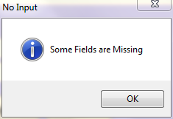

# Message Screen 2 Already Exist

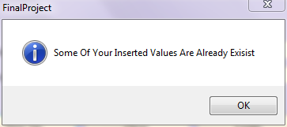

# Message Screen 3 Record Added Successfully

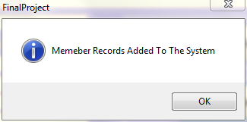

# Message Screen 4 Record Update Successfully

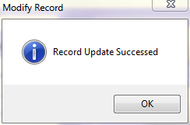

# Message Screen 4 Record Delete Successfully

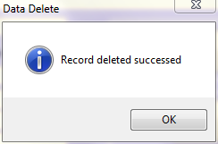

# Message Screen 4 Invalid Input

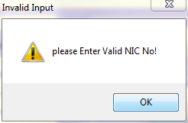

# Message Screen 4 Authentication Failed

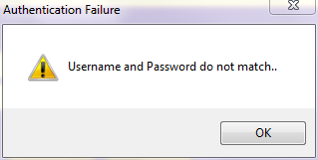

# Message Screen 4 Signup Complete

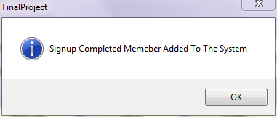

## Chapter 4

## Design of the proposed system

## Reports

# Reports List

|  |  |  |
| --- | --- | --- |
| **Report No** | **Report Name** | **Page No** |
| R1 | EPF Report | 115 |
| R2 | ETF Report | 116 |
| R3 | OT Report | 117 |
| R4 | Remittance Report | 118 |
| R5 | No pay Report | 119 |
| R6 | Payment Report | 120 |

# Report 1 EPF Report

**Report ID: 01**

**Report Name: EPF report**

**Report Description: EPF details**

**Chandana Apparel (pvt) Ltd.**

Ganewatta Road,

Kurunegala.

EPF Report

EPF Report for the month of …………………………………………… year……………………………………….

|  |  |  |  |  |  |
| --- | --- | --- | --- | --- | --- |
| Employee No | EPF No | Basic Salary | Employers Contribution To EPF | Employees Contribution To EPF | Total Contribution To EPF |
|  |  |  |  |  |  |

………………………………………….

HRM Manager

# Report 2 ETF Report

**Report ID: 02**

**Report Name: ETF report**

**Report Description: ETF details**

**Chandana Apparel (pvt) Ltd.**

Ganewatta Road,

Kurunegala.

ETF Report

ETF Report for the month of …………………………………………… year……………………………………….

|  |  |  |  |  |  |
| --- | --- | --- | --- | --- | --- |
| Employee No | ETF No | Basic Salary | Employers Contribution To ETF | Employees Contribution To ETF | Total Contribution To ETF |
|  |  |  |  |  |  |

………………………………………….

HRM Manager

# Report 3 OT Report

**Report ID: 03**

**Report Name: OT report**

**Report Description: OT details**

**Chandana Apparel (pvt) Ltd.**

Ganewatta Road,

Kurunegala.

OT Report

OT Report for the month of …………………………………………… year……………………………………….

|  |  |
| --- | --- |
| Employee No | OT Amount |
|  |  |

………………………………………….

HRM Manager

# Report 4 Remittance Report

**Report ID: 04**

**Report Name: Remittance list**

**Report Description: Sent salary info**

**Chandana Apparel (pvt) Ltd.**

Ganewatta Road,

Kurunegala.

Remittance Report

Remittance list for the month of …………………………………………… year……………………………………….

|  |  |  |
| --- | --- | --- |
| Emp No | Account Number | Amount |
|  |  |  |

………………………………………….

HRM Manager

# Report 4 No Pay Report

**Report ID: 04**

**Report Name: No pay report**

**Report Description: No pay details of the employee**

**Chandana Apparel (pvt) Ltd.**

Ganewatta Road,

Kurunegala.

No Pay Report

No Pay Report for the month of …………………………………………… year……………………………………….

|  |  |
| --- | --- |
| Employee Number | No Pay Report |
|  |  |

………………………………………….

HRM Manager

# Report 5 Payment Report

**Report ID: 05**

**Report Name: Payment report**

**Report Description: Payment details**

**Chandana Apparel (pvt) Ltd.**

Ganewatta Road,

Kurunegala.

Payment sheet

Pay sheet Report for the month of …………………………………………… year……………………………………….

|  |  |  |  |  |  |  |  |  |  |
| --- | --- | --- | --- | --- | --- | --- | --- | --- | --- |
| Emp No | Name | OT Hours | No Pay Days | Basic Sal | OT Amount | Gross Salary | EPF Contribution | No Pay Amount | Net Salary |
|  |  |  |  |  |  |  |  |  |  |

………………………………………….

HRM Manager

## Chapter 4

## Design of the proposed system

## VB.net Codes

# Adding Data to Employee Master File

Try

If (mycon.State = ConnectionState.Open) Then

mycon.Close()

Else

Dim value As Integer

countcal()

mycon.Open()

'TextBox2.Text = count

If (String.IsNullOrWhiteSpace(TextBox3.Text)) Then

MessageBox.Show("Please Enter First Name Field ", "No Input", MessageBoxButtons.OK, MessageBoxIcon.Warning)

ElseIf (String.IsNullOrWhiteSpace(TextBox4.Text)) Then

MessageBox.Show("Please Enter Last Name Field ", "No Input", MessageBoxButtons.OK, MessageBoxIcon.Warning)

ElseIf (String.IsNullOrWhiteSpace(TextBox5.Text)) Then

MessageBox.Show("Please Enter Address 1 Field ", "No Input", MessageBoxButtons.OK, MessageBoxIcon.Warning)

ElseIf (String.IsNullOrWhiteSpace(TextBox6.Text)) Then

MessageBox.Show("Please Enter Address 2 Field ", "No Input", MessageBoxButtons.OK, MessageBoxIcon.Warning)

ElseIf (String.IsNullOrWhiteSpace(TextBox7.Text)) Then

MessageBox.Show("Please Enter NIC Field ", "No Input", MessageBoxButtons.OK, MessageBoxIcon.Warning)

ElseIf (String.IsNullOrWhiteSpace(TextBox9.Text)) Then

MessageBox.Show("Please Enter Date Of Birth Field ", "No Input", MessageBoxButtons.OK, MessageBoxIcon.Warning)

ElseIf (String.IsNullOrWhiteSpace(TextBox11.Text)) Then

MessageBox.Show("Please Enter Designation Field ", "No Input", MessageBoxButtons.OK, MessageBoxIcon.Warning)

ElseIf (String.IsNullOrWhiteSpace(TextBox12.Text)) Then

MessageBox.Show("Please Enter Department Field ", "No Input", MessageBoxButtons.OK, MessageBoxIcon.Warning)

ElseIf (String.IsNullOrWhiteSpace(TextBox13.Text)) Then

MessageBox.Show("Please Enter Basic Salry Field ", "No Input", MessageBoxButtons.OK, MessageBoxIcon.Warning)

ElseIf (String.IsNullOrWhiteSpace(TextBox14.Text)) Then

MessageBox.Show("Please Enter Date Joined Field ", "No Input", MessageBoxButtons.OK, MessageBoxIcon.Warning)

ElseIf (String.IsNullOrWhiteSpace(TextBox15.Text)) Then

MessageBox.Show("Please Enter Telephone ", "No Input", MessageBoxButtons.OK, MessageBoxIcon.Warning)

ElseIf (String.IsNullOrWhiteSpace(TextBox15.Text)) Then

MessageBox.Show("Please Enter Different Telephone ", "No Input", MessageBoxButtons.OK, MessageBoxIcon.Warning)

ElseIf (String.IsNullOrWhiteSpace(TextBox1.Text)) Then

MessageBox.Show("Please Enter Bank Account No", "No Input", MessageBoxButtons.OK, MessageBoxIcon.Warning)

ElseIf (Not IsNumeric(TextBox7.Text)) Then

If value > 0 AndAlso value < 10 Then

value = value

Else

MessageBox.Show("please Enter Valid NIC No!", "Invalid Input", MessageBoxButtons.OK, MessageBoxIcon.Warning)

End If

ElseIf (Not IsNumeric(TextBox11.Text)) Then

If value > 0 AndAlso value < 1000 Then

value = value

Else

MessageBox.Show("please Enter Number For Designation No Field!", "Invalid Input", MessageBoxButtons.OK, MessageBoxIcon.Warning)

End If

ElseIf (Not IsNumeric(TextBox12.Text)) Then

If value > 0 AndAlso value < 5 Then

value = value

Else

MessageBox.Show("please Enter Number For Department No Field!", "Invalid Input", MessageBoxButtons.OK, MessageBoxIcon.Warning)

End If

ElseIf (Not IsNumeric(TextBox13.Text)) Then

If value > 0 AndAlso value < 400000 Then

value = value

Else

MessageBox.Show("please Enter Number For Basic Salary Field!", "Invalid Input", MessageBoxButtons.OK, MessageBoxIcon.Warning)

End If

ElseIf (Not IsNumeric(TextBox14.Text)) Then

If value > 0 AndAlso value < 8 Then

value = value

Else

MessageBox.Show("please Enter Number For Date Joined Field!", "Invalid Input", MessageBoxButtons.OK, MessageBoxIcon.Warning)

End If

ElseIf (Not IsNumeric(TextBox15.Text)) Then

If value > 0 AndAlso value < 10 Then

value = value

Else

MessageBox.Show("please Enter Number For Telephone No Field!", "Invalid Input", MessageBoxButtons.OK, MessageBoxIcon.Warning)

End If

ElseIf (Not IsNumeric(TextBox16.Text)) Then

If value > 0 AndAlso value < 10 Then

value = value

Else

MessageBox.Show("please Enter Number For Different Telephone No Field!", "Invalid Input", MessageBoxButtons.OK, MessageBoxIcon.Warning)

End If

ElseIf (Not IsNumeric(TextBox1.Text)) Then

If value > 0 AndAlso value < 1000 Then

value = value

Else

MessageBox.Show("please Enter Number For Valid Bank Account No Field!", "Invalid Input", MessageBoxButtons.OK, MessageBoxIcon.Warning)

End If

Else

If (RadioButton1.Checked) Then

sex = "Male"

End If

If (RadioButton2.Checked) Then

sex = "Female"

End If

Dim com1 As String

Dim com2 As String

com1 = ComboBox1.SelectedItem.ToString

com2 = ComboBox2.SelectedItem.ToString

Try

cmdinsert.CommandText = "INSERT INTO employee VALUES('" & TextBox2.Text & "','" & TextBox3.Text & "','" & TextBox4.Text & "','" & TextBox5.Text & "','" & TextBox6.Text & "','" & TextBox7.Text & "','" & sex & "','" & TextBox9.Text & "','" & com1 & "','" & TextBox11.Text & "','" & TextBox11.Text & "','" & TextBox13.Text & "','" & TextBox14.Text & "','" & com2 & "','" & TextBox16.Text & "','" & TextBox15.Text & "','" & TextBox1.Text & "')"

cmdinsert.CommandType = CommandType.Text

cmdinsert.Connection = mycon

cmdinsert.ExecuteNonQuery()

MsgBox("Memeber Records Added To The System", MsgBoxStyle.Information)

mycon.Close()

countcal()

defaulter()

Catch ex As Exception

MsgBox("Some Of Your Inserted Values Are Already Exisist", MsgBoxStyle.Information)

MsgBox(ex.Message, MsgBoxStyle.Information)

mycon.Close()

End Try

End If

End If

Catch ec As Exception

MsgBox("Database Connection Error Occured ", MsgBoxStyle.Information)

End Try

mycon.Close()

# Modify Data from Employee Master File

If (mycon.State = ConnectionState.Open) Then

mycon.Close()

Else

mycon.Open()

countcal()

Dim com1 As String

Dim com2 As String

com1 = ComboBox1.SelectedItem.ToString

com2 = ComboBox2.SelectedItem.ToString

Try

mycon.Open()

Dim up As New OleDbCommand

up.CommandText = "UPDATE employee SET First_Name='" & TextBox3.Text & "',Last_Name='" & TextBox4.Text & "',Address_1='" & TextBox5.Text & "',Address_2='" & TextBox6.Text & "',NIC='" & TextBox7.Text & "',Sex='" & sex & "',Date_Of_Birth='" & TextBox9.Text & "',Marriage='" & com1 & "',Designation='" & TextBox11.Text & "',Department='" & TextBox12.Text & "',Basic_Salary='" & TextBox13.Text & "',Joined='" & TextBox14.Text & "',Status='" & com2 & "',Tel_1='" & TextBox16.Text & "',Tel_2='" & TextBox15.Text & "',Bank_Acc='" & TextBox1.Text & "' WHERE Emp_No=" & TextBox2.Text & ""

up.CommandType = CommandType.Text

up.Connection = mycon

up.ExecuteNonQuery()

MsgBox("Record Update Successed", MsgBoxStyle.Information, "Modify Record")

countcal()

defaulter()

Catch er As Exception

MsgBox(er.Message)

End Try

End If

# Delete Data from Employee Master File

If (mycon.State = ConnectionState.Open) Then

mycon.Close()

Else

mycon.Open()

countcal()

TextBox2.Text = count

Dim up As New OleDbCommand

Dim co As Integer

Try

mycon.Open()

co = TextBox2.Text

up.CommandText = "DELETE FROM employee WHERE emp_No=" & co & ""

up.CommandType = CommandType.Text

up.Connection = mycon

up.ExecuteNonQuery()

MsgBox("Record deleted successed", MsgBoxStyle.Information, "Data Delete")

countcal()

defaulter()

Catch rt As Exception

MsgBox(rt.Message)

End Try

mycon.Close()

End If

# Requirements

**Hardware**

Intel Pentium ш Higher Processor

256 MB RAM

40 GB HDD

**Software**

Microsoft Access 2007

Microsoft .net Framework 4.0

**Live ware**

System Administrator

Database Administrator

**Environment**

Microsoft .net Framework 4.0

# Cost Benefits of the System

Money is needed to buy software we need as mentioned in requirements and we should trained an employee to handle this software in a good manner if not whole system will give errors. Approximately we need LKR. 50000 amount of money to implement this software.

**Here are some benefits of this computerized system**

## 1) Time Saving

If a company invests in [payroll software](http://small-business-software.iris.co.uk/free_trial.aspx) it can reduce the amount of man hours spent on this particular area – because the system is automated. This means that once a clerk inputs the initial data it will work out individual employee tax deductions automatically, until the original information is altered.

## 2) Recordkeeping

For firms that adopt this [small business software](http://small-business-software.iris.co.uk/free_trial.aspx) it also means that they can keep on top of employee sick leave, holidays and personal time very efficiently. Furthermore, it means that those working in the accounts department can make reports with extremely accurate data rather than sifting through hand-written ledgers, allowing them to do their job more effectively.

## 3) Planning and reporting

This in turn means that company owners and managers are provided with the best data about their organization’s funds.  It also means that they can forecast labor costs that interact with budgeting and accounting programmers that allows them to make more calculated decisions on where to take the business in the future.

## 4) Saving money

Sometimes it’s important to save the best till last, and this is one of those instances. By adopting payroll software small firms can reduce the amount of positions needed in payroll as the system is automated – but because the technology is so efficient it means that money isn’t lost through paying the incorrect amount of tax or not paying staff on time.

**5) Easy calculations**

 Efficiency in payroll calculation is important in every company. It requires accuracy to pay employees the right amount of money they have earned. To avoid the hassles of calculating payroll manually, you can use software to automate the process. The process is productive and effective in saving time and money. Your accounting department can create reports and financial documentation easily.

**6) Forecasting**

 When you have payroll software, it allows you to see and monitor all payroll expenses instantly. This helps you graph financial data to help you create a forecast. If you have an idea of your business performance, it will be easier to decide when you need to hire new staff for the company. You can make adjustments and calculate salary increases to help you make an assessment on how it will affect your money. It is easier to know whether your decision is good for the business.

**7) Reliable backup**

As a business, keeping large amounts of data for payroll can be challenging. You can’t store piles of papers and data manually. But when you are using payroll software, it is convenient to save records in various databases available online. In case your computer or system is destroyed, you should still have a backup to get all your records back.

# Final Conclusion

The system study that we have carried out in this report is based on the manual system of Chandana Apparel Pay roll System. Through the introduced computerized system organization’s requirements are met to the requested level, providing efficient and effective functionality, security actions, and up-to-date reports to review the functionality of the organization as some of the major improvements.

As results of this introduced computerized system have given the organization much more efficient and effective system compared to their manual system.

The main aim of this project was to how to develop pay roll system and we were able to finish that successfully.

# 

# Thank You